S&P 500 Component Changes

Table of Contents

Motivation 2

S&P 500 Historical Components & Composition Changes 2

Dataset 3

Event Effects 4

Option Implied Volatility Skew Study Statistics 6

Stock Strategies 9

Framework 9

Strategy 1 10

Strategy 2 11

Final Strategy 12

Timing the exit 13

Out of sample results 14

What happened? 15

Conclusion 17

Extensions 17

References and readings 18

# Motivation

We aim to study the behavior of implied volatilities and stock returns around the S&P 500 index re-composition and attempt to identify profitable options and/or equity trading strategies. While there is significant literature on stock drift around these events, we also want to look at options - studies have shown that options markets have more well-informed participants. We therefore investigate if there is any anticipatory price action that manifests as implied volatility changes leading up to announcements. To this end, we also look at the implied volatility skews leading up to, during and after the event to look for systematic patterns, if any.

# S&P 500 Historical Components & Composition Changes

The S&P 500 index consists of 500 large companies listed on the NYSE or NASDAQ stock exchanges. It is one of the most commonly followed equity indices and many consider it one of the best representations of the US stock market.

The components of the index are updated periodically, typically in response to acquisitions and spin-offs, or to keep the index up to date as companies grow or shrink in value. In other words, they are not on a fixed schedule but are made as needed. The changes themselves are determined by the S&P index committee, which makes its decisions behind closed doors based on market capitalization, industry representation, liquidity, trading volume, and financial soundness. Market capitalization is a very important criterion, but from an investor's point of view significant residual uncertainty remains about index changes. Over the past 50 years there have been around 1200 component changes to the S&P 500 index or around 24 per year. Changes and announcements are always made after the close of trading.

Studies have concluded that an addition to the S&P 500 index has a positive impact for a company’s share price. For example, in 1997, Lynch and Menemsha proved a positive abnormal return for shares added to the index of about 3.8% over the period starting the day after the announcement and ending the day before the effective date of the change. Similarly, they showed that the removal of a company from the index causes significant decrease in stock prices. More recently, in 2014, Bernard explored this topic from the perspective of fund managers and came to similar conclusions although his study indicated that the effect of index changes on stock prices has reduced in more recent times.

This at least partly be explained by the so-called Index effect. Over the past decade there has been a massive inflow of capital into passively managed funds that are designed to track an underlying index such as the S&P 500. Those funds aim to minimize tracking error which is the difference between the funds return and the underlying indexes return. This compels fund managers to respond rapidly to changes to index constituents by buying those entering the index and selling those leaving. Furthermore, since the market capitalization of the entering and exiting companies rarely match exactly, some rebalancing of all remaining stocks must also take place.

Since October 1989 changes to the S&P 500 index are announced beforehand and the general guideline is that announcements are made 5 days before the effective change date. This creates an interesting dynamic in the market and a predictable imbalance in the supply and demand of stocks entering or leaving the index. In 2013 S&P estimated that the total amount passively tracking the S&P 500 index was over 10% of the indexes total market capitalization. This means that at that point in time one could assume that passive funds tracking the index would in total have to acquire (get rid of) 10% of a company’s float when it entered (left) the index. This by itself would create problems for fund managers due to limited liquidity of some stocks but in addition, since all fund managers want to minimize their tracking error, they all want make the changes at the same time and to top it off the rest of the market knows all of this in advance. Thus, it is reasonable to assume that the stock price of companies entering the index will drift upwards from announcement date to change date due to excess demand and similarly drift downwards for companies leaving the index due to excess supply. From a fund manager’s perspective, this poses a problem since he will face of trade-off between minimizing his tracking error and minimizing his slippage or trading costs. On the other hand, this creates an opportunity for other market participants which can take advantage of the situation by trading in advance of the funds, hoping to catch the drift of the stock price of companies entering or leaving the index.

Additions to the index are caused by two kinds of events: S&P decide to add into the index a stock that is already listed and traded. In this case the index fund managers need to actively buy the newly added stock. Note that the stock must be listed for some minimum period before it can be considered for entry in the index.

A company already listed in the S&P 500 index spins off a new entity and S&P decide to include the spin off in the index. These new spin offs do not require any trading from the manager, aside from the corresponding deletion of smaller stock.

Deletions from the index are of three kinds: Deletions decided by S&P that require the manager to trade out of their existing stock positions. Stocks are acquired by a company either inside or outside of the SP500 index - these do not require any action from the manager, except some rebalancing or reinvestment of cash proceeds. Finally, there are rare cases where deletions occur because a stock has been delisted. This corresponds to a variety of situations.

# Dataset

The historical changes in the components of the index have been obtained from a dataset provided by Sibil Research (siblisresearch.com). The dataset provides the dates and details of the constituent changes, including the announcement dates and sector classification of the added and removed stocks.  In the period from January 1996 to August 2013, for which we have stock prices and options prices (if any), we have a total number of 497 changes in the composition of the index. Among these 497 stocks removed we have 212 stocks that have not been removed from the index due to a take over. The added and removed components tickers have been matched with the tickers from the IVY database to obtain the security ID of the stocks considered. We looked at each single change from 1996 to 2013 to understand if the security ID selected from the above matching was right and to classify each of the removed stocks as being removed because of a takeover taking place or not.

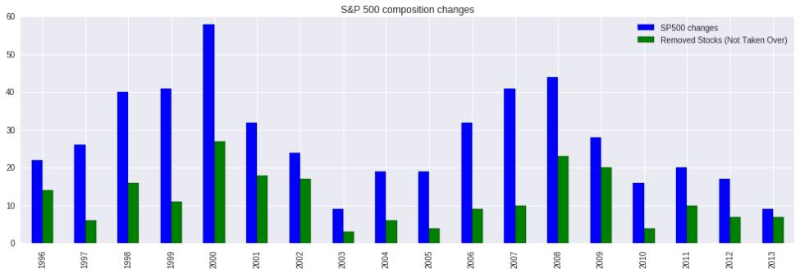

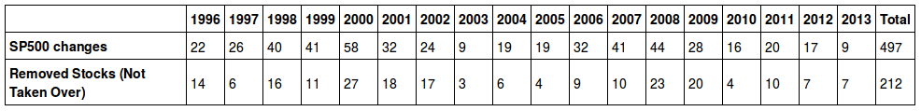

## Event Effects

Following the announcement of a change in the composition of the S&P 500, index tracking funds will have to execute substantial purchases of the added stock while upon announcement arbitrageurs bid up the price of these shares in anticipation to the change date. Announcement dates are unscheduled events while change dates are scheduled at the time the composition change is announced. In 30 changes out of the 497 we have considered the change date for the added and removed stock do not coincide. Moreover, in some cases, the length of the time window between the two dates does exceed the general rule of 5 days as can be seen from the following tables.

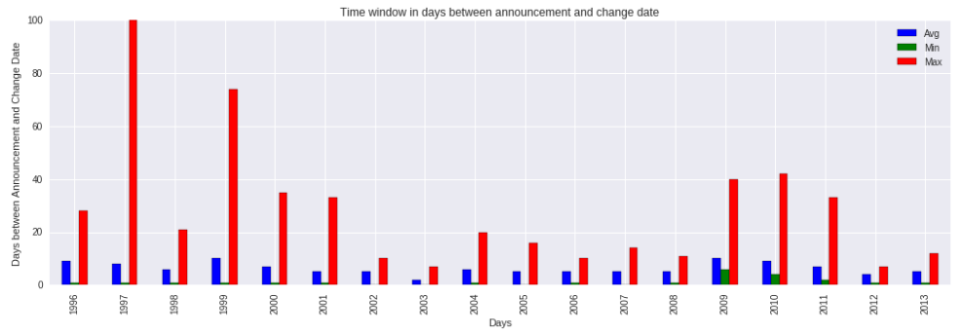

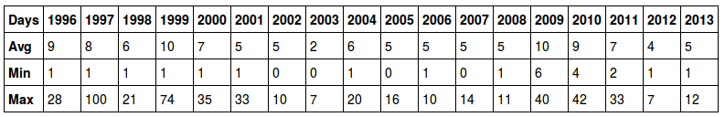

In order to asses the impact of these events on the stock price and trading activity, we have looked at stock trading volumes and returns in a time period around the recomposition event. The following graph shows a recurrent pattern across the events we have considered, i.e. a positive drift for the entering stock, a negative drift for the existing stock and a huge spike in volume for both stocks on change date.  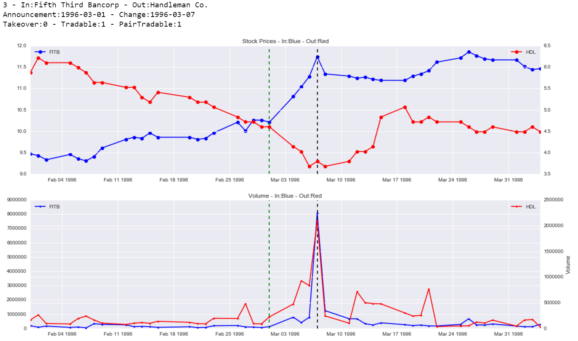

The following table shows the abnormal trading volume on announcement date, change date and the announcement to change date window expressed by the average ratio between these quantities to the average volume over the last year (if available).

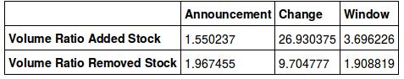

The impact of these events on stock returns has also been analyzed. The following table summarizes the average daily returns of SPDR S&P 500 ETF (SPY), added and removed stocks during all of the announcement to change date windows considered.

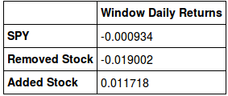

It is evident that stock prices actually exhibit on average a positive or negative drift in response to index change announcements within the announcement to change date window. As can be seen in the following plots, this effect is also reflected in the average stock price path of an added and removed stock in a -10,+10 trading days window around the change date.

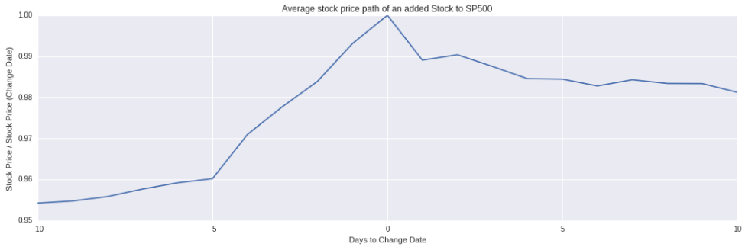

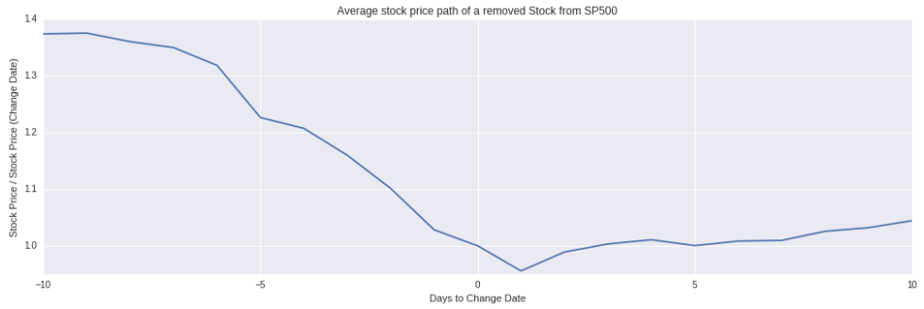

These findings suggest that it may be possible to implement stock trading strategies to take advantage of this systematic behaviour on these events.

# Option Implied Volatility Skew Study Statistics

It has been shown that information contained in the options market can be used to forecast future stock returns. Many practitioners view the equity option market as a primary source of information about the expected return, risk and sentiment of individual stocks and the equity market in general. We want to investigate what kind of impact, if any, addition or removal of a stock from the SP500 has on the implied volatilities of the options expiring after the SP500 components change and having the shortest time to maturity (front options). In order to do so we have focused our attention on implied volatilities of ATM and OTM calls and puts of the entering (exiting) stocks in a time window of 30 days before the announcement to 5 days after the change date. As demand for long (short) positions on the stock may change due to the rebalancing of index tracking portfolios, we hope to see some kind of signature in the evolution of the volatility smile of the front options. As it has been argued in the literature that traders prefer to exploit private information by trading in the option market because of the reduced short selling constraints and the increased financial leverage.

There are three measures of interest that we have considered and that could reveal some kind of signature in the volatility smile: ATM skew, OTM put skew and OTM call skew.  ATM volatility skew, defined as the difference between ATM put and ATM call, relates to the trading activity of informed investors and jump premia. A high value of ATM skew should be related with expected underperforming stock returns. OTM put skew, defined as the difference between the implied volatilities of out-of-the-money put and at-the-money call options, commonly referred to as the out-of-the-money volatility skew, reflects the (informed) worries investors have about negative price movements. If investors have a negative perception about a certain stock they would tend to buy put options either for protection against, or speculation about future stock price drops. This increase in the demand for put options leads to a higher price and implied volatility, yielding a steeper volatility smile. Conversely, the OTM call skew, defined as the difference between the implied volatilities of OTM call and ATM put options reflects the positive perception about a certain stock.

In our study we have analyzed front options for each addition or removal event in a window of 30 days before announcement date and 5 days after change date. Options with MBBO<=$0.25 and open interest equal to zero have been discarded, while implied volatilities have been calculated using a binomial tree pricer when the optimization had a converging solution. Only roughly 15% of the added and removed stocks had front options trading for at least 30 days prior to change date.

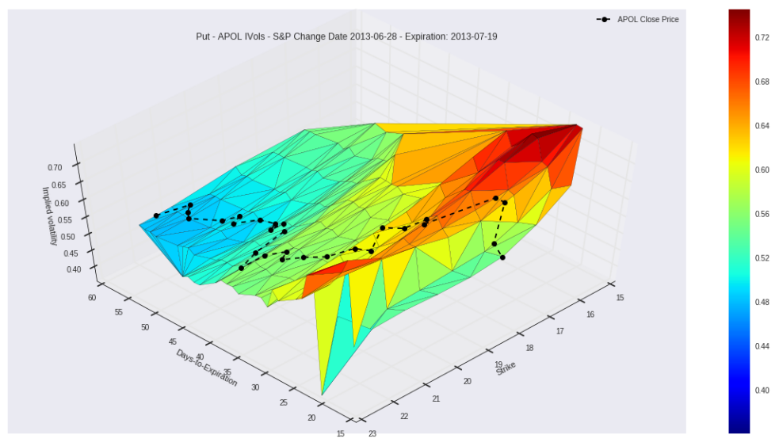

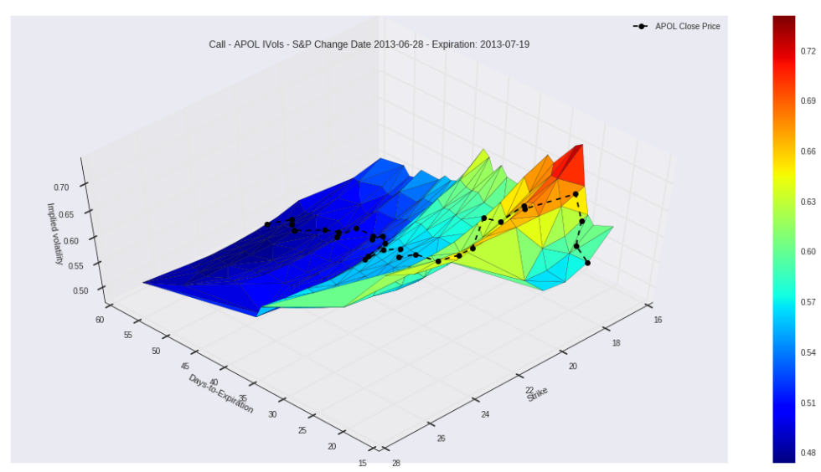

The ATM and OTM implied volatilities have been calculated by interpolating the moneyness of the real strikes against the calculate implied volatilities and defining ATM options with moneyness equal to 1 and OTM puts and calls having respectively moneyness equal to 0.95 and 1.05. Due to the small number of traded strikes, in some cases we were not able to obtain the ATM and OTM interpolated implied volatilities.

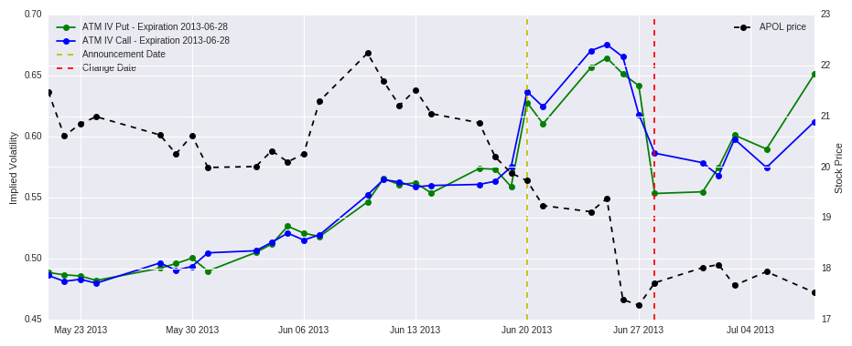

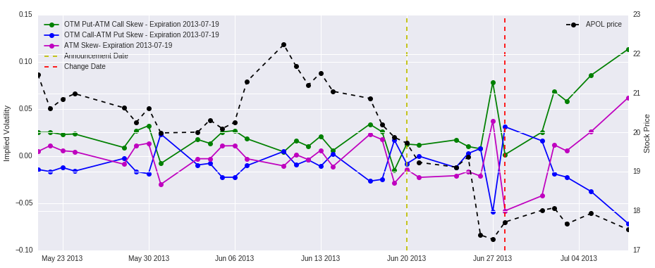

# Stock Strategies

We wanted to see if one could take advantage of the expected rise(fall) in the stock share price from announcement of the composition change to the actual effective change date.

It is important between types of index changes when conducting research such as this one. The most important events are when the index committee decides to make a change based on their selection criteria. For example, when a company outside of the index has grown rapidly and passed a company in the index in market cap. In those cases passive funds will need to add the company entering the index to their portfolio and get rid of the company leaving the index. This creates trading opportunities on both sides.

Other index changes will usually only require passive funds to trade either the entering or leaving company and thus only create a supply and demand imbalance for one company. For example, when a company that is a part of the index is taken over by another or taken of the market. Another example is when a company that is already a part of the index spins off another company such that both parts are still large enough to be a part of the index.

## Framework

We loaded external data into XF database and created a customizable framework to test trading strategies and created a framework that allows us to test dispersion trading strategies on the index change events. A fixed amount is allocated to each trade with options for offsetting the open and close of the trade relative to the announcement and change dates. All trades are also logged in a separate text file.

See GetData_19962013.sql for data collection process

See TradeSPChanges.py for the trading strategy implementation

See trade logs in the TradeLogs folder or strategy results

## Strategy 1

We started by testing a strategy that trades only the stocks entering the index. That way we can trade on all the announcements while that is not possible if we wanted to pair trade the stocks entering and leaving the index since a majority of the index changes are due to mergers and take-overs and in those cases the stock leaving the index is not tradable.

Strategy: Long the stock entering the index and short the S&P500 index from announcement to change date.

Goal: Take advantage of abnormal excess returns (positive) of stocks entering the index.

Details: Open trade on the morning after the announcement is made. Short the index through the SPY ETF and use proceeds to go long the stock entering the index. Close trade at close of trading on the effective change date (sell the stock and buy back SPY shares)

Results: Running this strategy from the beginning of 1996 to August 2013 we can see that on average the trades are profitable and the return distribution is positively skewed (large absolute returns are mostly positive). The standard deviation is relatively high compared to the average so the Sharpe ratio of this strategy is low. The strategy was very profitable from 1996 until the early 2000's, after that the performance really slows down and then after the financial crisis the performance is negative.

Analysis: Hard to explain why exactly it not profitable any more. There has been a big increase in capital invested in passive funds in recent time which should amplify the phenomenon but the profitability has gone away. Fund managers are able to reduce their market impact and are smarter around these events.

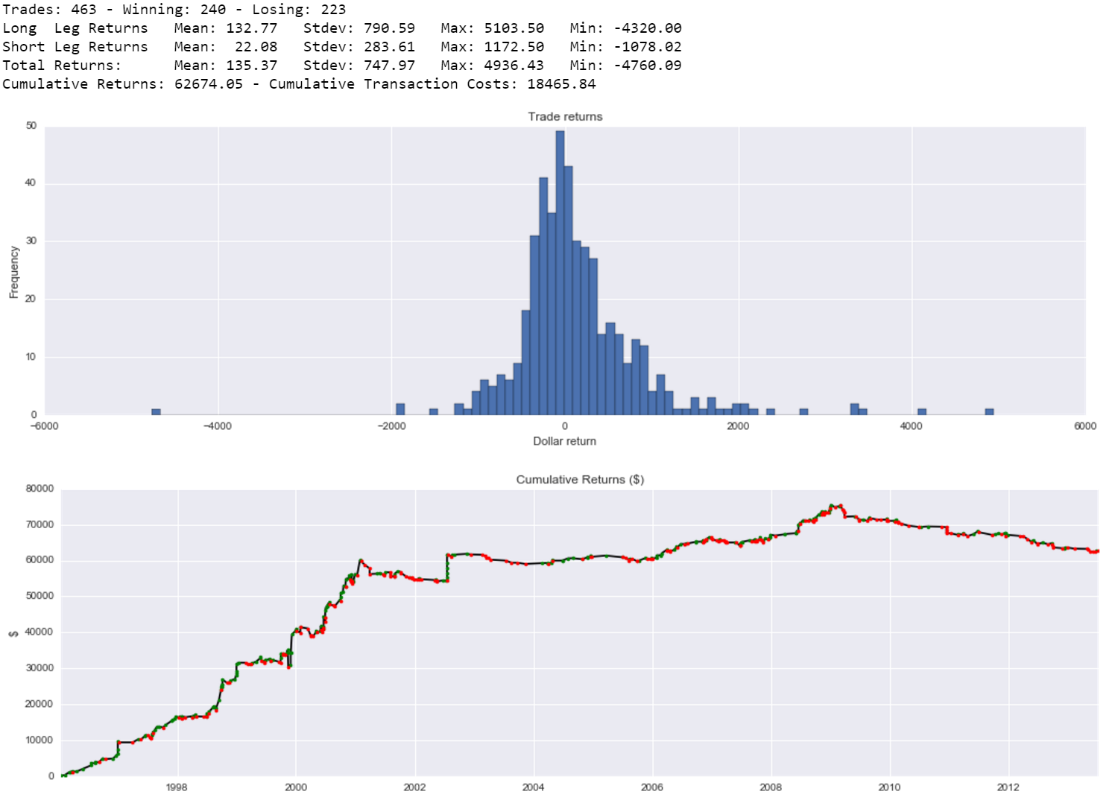

## Strategy 2

Next we tested a pairs trading strategy on a subset of the announcements where the changes were not due to a merger or takeover, i.e. cases where the stock leaving the index is tradable around the announcement.

Strategy: Long the stock entering the index and short the stock leaving the index from announcement to change date.

Goal: Take advantage of abnormal excess returns of both stocks entering (positive) and leaving (negative) the index.

Details: Open trade on the morning after the announcement is made. Short the stock leaving the index and use proceeds to go long the stock entering the index. Close trade at close of trading on the effective change date (close long position then exit short).

Results: This strategy is more profitable on average than the previous one and the return distribution is also very positively skewed. Both legs of the trade are profitable on average but trading the stocks leaving the index is much more profitable. Intuatively this makes sense since if a stock is being removed from the index it is more than likely that it has been underperforming in recent times and therefore that it's stock price has a negative momentum. The cumulative return profile is simlar to the profile of the previous strategy, very profitable until the early 2000's then it levels out until the crisis. During the crisis it was again pretty profitable and the momentum arguement applies again there. The stocks leaving the index during the crisis were most likely having big troubles due to the state of the markets and the economy. After the crisis the strategy has been pretty useless and has performed negatively if anything.

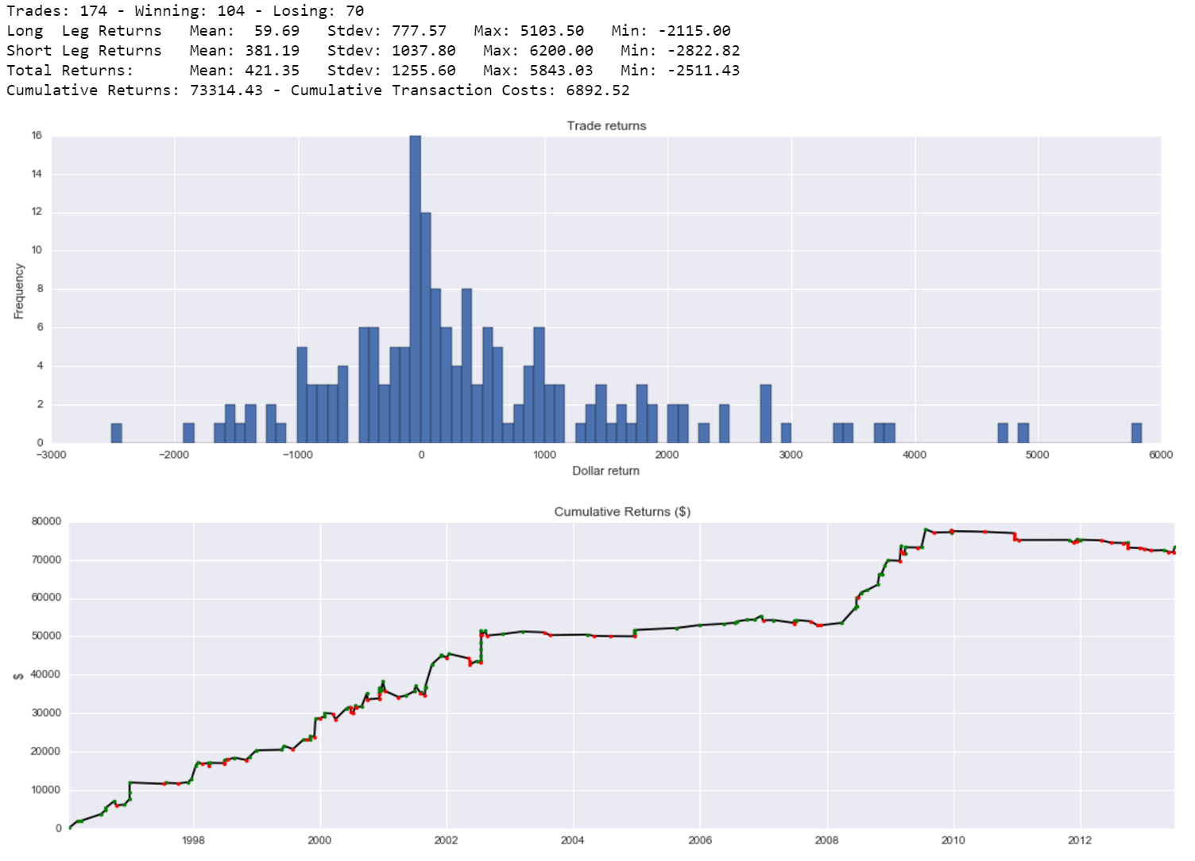

## Final Strategy

Finally since both approaches were profitable on average and since the pair trading scheme performed better we set up a strategy that combined the two strategies. We trade on all index change announcements, if the change is not forced, i.e. not due to a merger or take-over, we pair trade the stocks entering and leaving the index. But if the change is due to a merger or take-over we only trade the stock entering the index against the S&P500 index.

Strategy: Long the stock entering the index and short the stock leaving the index or the S&P500 index (depending on if the change is due to a take-over or not) from announcement to change date.

Goal: Take advantage of abnormal excess returns of stocks entering (positive) and leaving (negative) the index when possible, otherwise take advantage of stocks entering the index only.

Details: Open trade on the morning after the announcement is made. Short the stock leaving the index or the index itself through the SPY ETF and use proceeds to go long the stock entering the index. Close trade at close of trading on the effective change date.

Results: This strategy is the most profitable out of the three, as is expected it has a lower average return than the isolated pair trading scheme but it has three times as many trading opportunities so running this strategy from the beginning of 1996 to August 2013 results in the highest cumulative return. Cumulative return profile same as pair trading scheme and the return distribution is still positively skewed.

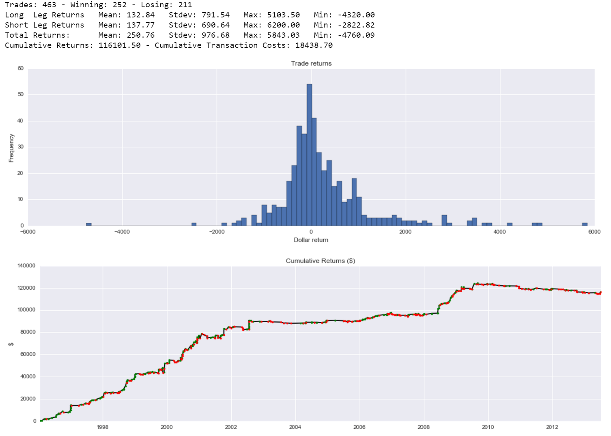

### Timing the exit

We tested variations of when to close the trade 5 days before effective to 5 days after the effective change date. It turns out that it is actually slightly more profitable, during the period that we looked at, to close the position one day after the actual change date (If we are trading the stock that is exiting the index). This agrees with the plot of the average movement we saw earlier. However, that effect if mainly from 1996 until the early 2000's and it looks like there was on average a one day delay in the reaction to the stock removal.

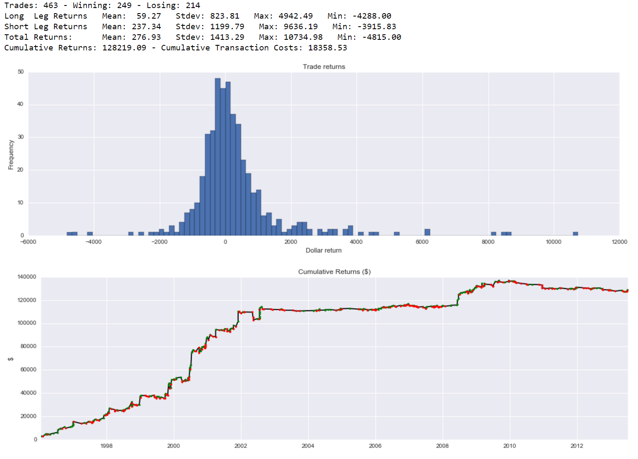

## Out of sample results

* All rebalancing events from Sep 2013 to Apr 2016
* Stock data from IVY through Wharton’s WRDS
* Final strategy setup – Exit on effective change date
  + Not profitable

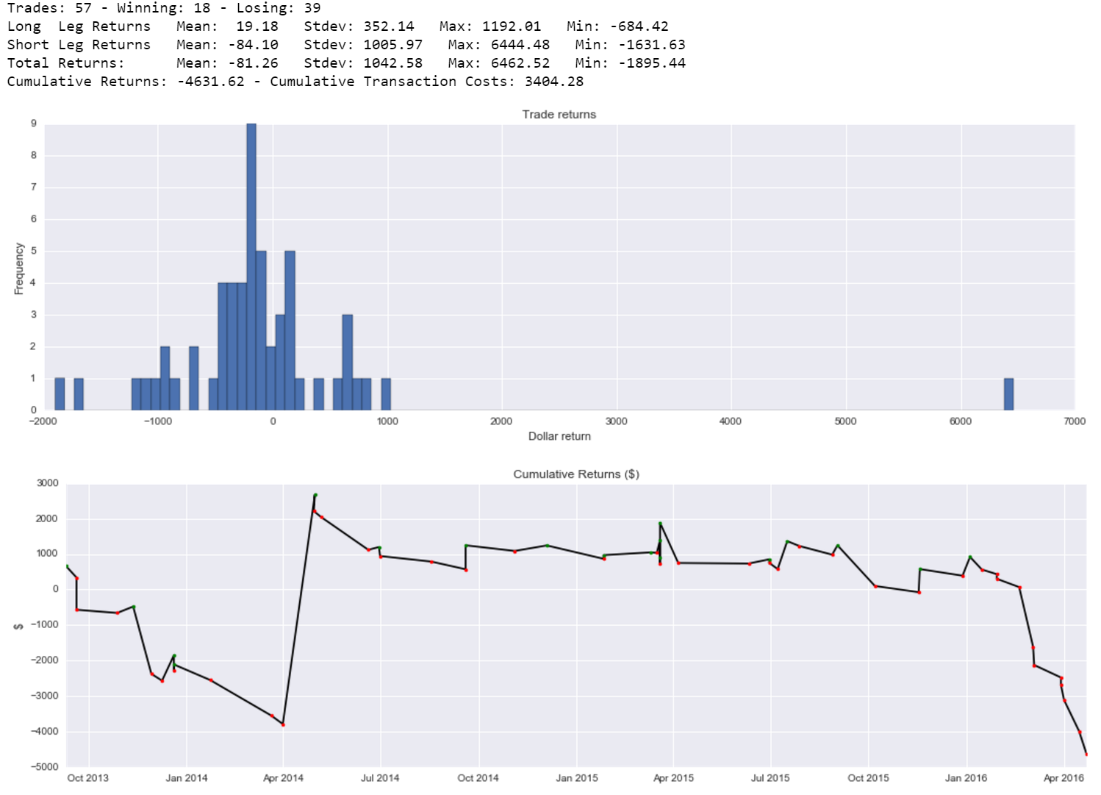

## What happened?

Massive inflows into passive index tracking funds in recent decade **so** Index Effect should be stronger

Is this a timing issue?Tested final strategy where the trade is entered immediately after announcement, during after hours trading on previous close price.Idealized case and impossible to do consistently**:** Volume is limited during after hours and prices are volatileand **c**ompetition with HFT

We evaluated the final strategy if one could open the trade immediately after the announcement, so during after hours trading on the announcement date. Which in reality is impossible but the results are interesting, almost 80% of the trades are profitable and the strategy remains somewhat profitable throughout the whole period of interest. Incredibly profitable from 1996 to until the early 2000's, after that the performance really slows down but doesn't turn negative as before. This is just done out of curiosity, but it does tell us that the effect is still there and there are opportunities to profit but it is hard to capture, especially in more recent times. Timing likely not the only issue.

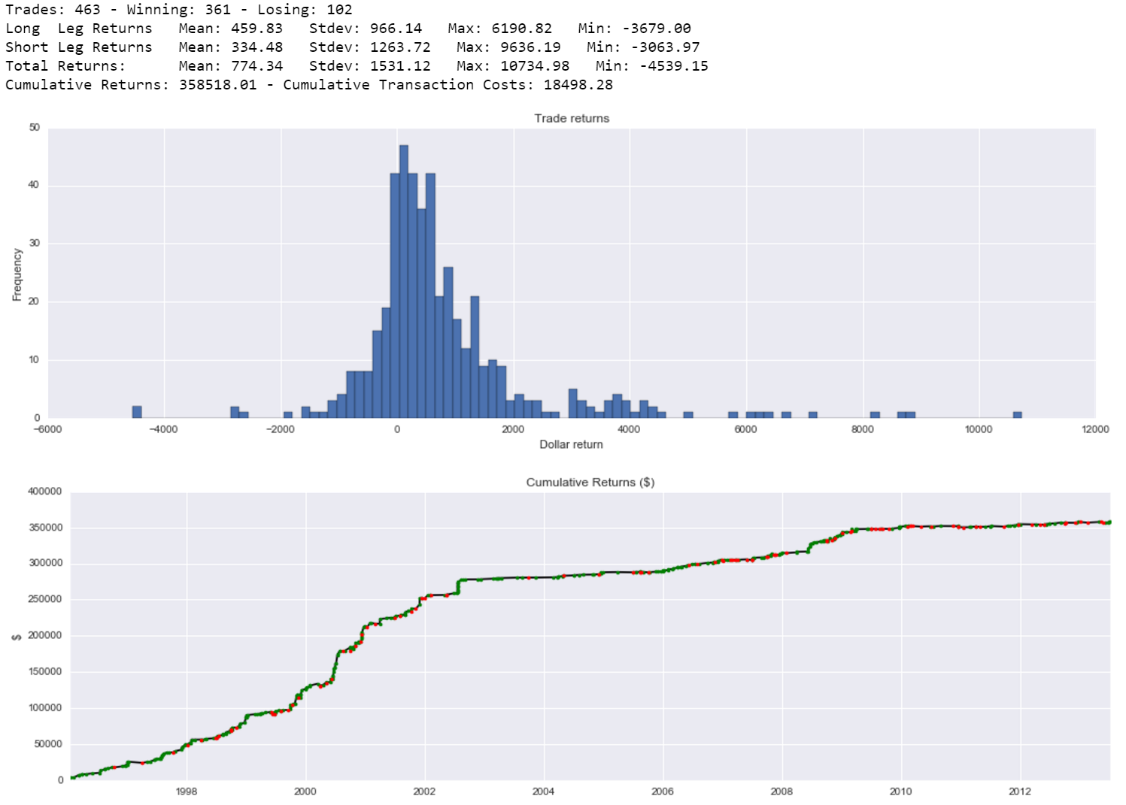

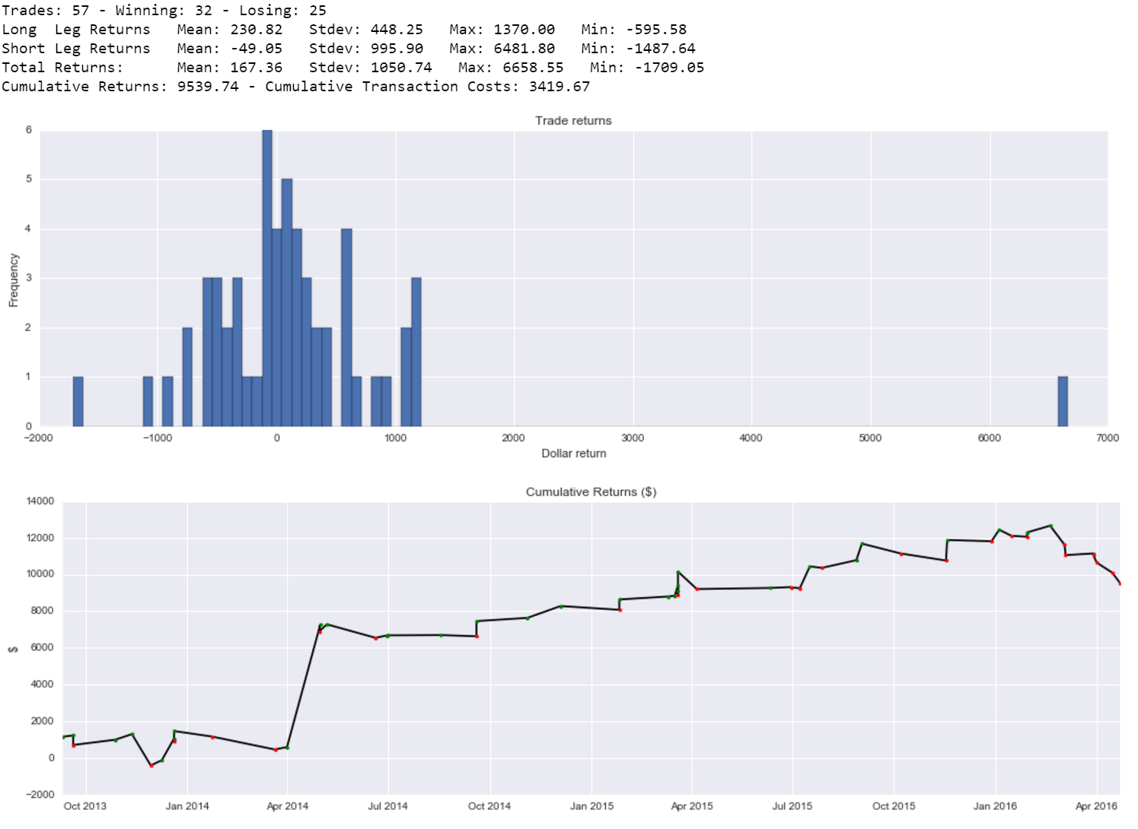

# Conclusion

Simple dispersion strategies very profitable from 1996 until early 2000’s.

Not worthwhile to pursue in todays market even though underlying effect should be stronger.

Why is this not profitable anymore?

* Awareness
  + Earliest research dates back to 80’s but there was some interest in the topic in the early 2000’s. Data driven research as data vendors enter the market.
* Anticipation
  + Smart fund managers might try to anticipate changes beforehand. The criteria that the S&P index committee is somewhat transparent but there is always some uncertainty.
* Markets
  + Fund managers employing smarter execution methods, reducing market impact.
  + After hours trading. All of the announcements are made after the close of the market. Studies suggest that a majority of the effect is captured during after-hours trading.

## Extensions

With the previous example in mind one could hope to take advantage of this phenomenon by anticipating index changes. You could monitor the criteria that the S&P500 index committee uses to evaluate eligble companies (which public information) for a selection of stocks and react to cases where the probability that a stock will be selected for additition or deletion from the index is high. Example: If a stock is likely to be removed from the index then identify the stock that is most likely to replace it and go long that stock and short the stock in the index. With some pre-determined hyperparameters (stop-loss, maximum duration of trade, etc.)

The S&P500 index is the index that is mostly widely tracked by passive funds and investors. Even though the profitability of the dispersion strategy is pretty low in recent times there could exist opportunities for indexes. For example the Russell indexes or sector based indexes;.

# References and readings

<http://siblisresearch.com/data/historical-components-sp-500/>

<http://us.spindices.com/documents/methodologies/methodology-sp-us-indices.pdf>

<https://en.wikipedia.org/wiki/S%26P_500_Index>

<http://siblisresearch.com/data/historical-components-sp-500/>

<http://www.signalplot.com/index-front-running-what-happens-when-a-stock-is-added-to-an-index/>

Annual Survey of Indexed Assets as of December 2012

<http://pages.stern.nyu.edu/~alynch/pdfs/jb97lm.pdf>

<http://www.valuewalk.com/wp-content/uploads/2015/07/WWP_HiddenCosts_final_revised.pdf>

<http://finance.yahoo.com/news/front-running-p-500-etf-133023440.html>

<http://citeseerx.ist.psu.edu/viewdoc/download?doi=10.1.1.421.6728&rep=rep1&type=pdf>

<http://kiddynamitesworld.com/where-bloomberg-discovers-that-large-orders-have-market-impact/>

<http://cc.jlu.edu.cn/G2S/eWebEditor/uploadfile/20130506101046214.pdf>

<https://www.newyorkfed.org/medialibrary/media/research/staff_reports/sr484.pdf>

<http://www.petajisto.net/papers/petajisto%202011%20jef%20-%20hidden%20cost%20for%20index%20funds.pdf>

<http://www.thetradenews.com/magazine/The-TRADE-Magazine/2007/December/Understanding-index-front-running/>

<https://www.spice-indices.com/idpfiles/spice-assets/resources/public/documents/155946_americanair1agn5.pdf?force_download=true>

<http://www.wsj.com/articles/SB962754368837494226>